**PART 1 : SDG SELECTION AND PROBLEM DEFINITION**

## **SDG: Good Health and Well-Being**

### **Overview**

**Goal:**

Ensure healthy lives and promote well-being for all at all ages.

**Background:**

SDG aims to improve global health by reducing the burden of disease, improving access to quality healthcare services, and promoting preventive measures to address health issues. This goal encompasses a broad range of health-related objectives, including reducing maternal and child mortality, combating infectious diseases, promoting mental health, and ensuring universal health coverage.

### **Targets and Indicators**

SDG includes several specific targets that are measurable by indicators:

1. **Maternal Mortality**
   * **Target 3.1:** Reduce the global maternal mortality ratio to less than 70 per 100,000 live births by 2030.
   * **Indicator 3.1.1:** Maternal mortality ratio.
2. **End Preventable Deaths of Newborns and Children**
   * **Target 3.2:** End preventable deaths of newborns and children under 5 years of age, aiming to reduce neonatal mortality to at least as low as 12 per 1,000 live births and under-5 mortality to at least as low as 25 per 1,000 live births by 2030.
   * **Indicator 3.2.1:** Under-5 mortality rate.
   * **Indicator 3.2.2:** Neonatal mortality rate.
3. **Combat Diseases**
   * **Target 3.3:** End the epidemics of AIDS, tuberculosis, malaria, and neglected tropical diseases and combat hepatitis, water-borne diseases, and other communicable diseases by 2030.
   * **Indicator 3.3.1:** Number of new HIV infections per 1,000 uninfected population.
4. **Universal Health Coverage**
   * **Target 3.8:** Achieve universal health coverage (UHC), including financial risk protection, access to quality essential health-care services, and access to safe, effective, quality, and affordable essential medicines and vaccines for all.
   * **Indicator 3.8.1:** Coverage of essential health services.
   * **Indicator 3.8.2:** Proportion of population with large household expenditures on health as a share of total household expenditure or income.
5. **Health Financing and Workforce**
   * **Target 3.c:** Substantially increase health financing and the recruitment, development, training, and retention of the health workforce in developing countries, especially in least developed countries and small island developing States.
   * **Indicator 3.c.1:** Health worker density and distribution.

### **Challenges**

Despite progress in some areas, significant challenges remain:

* **Healthcare Access:** Many populations, particularly in rural or underserved areas, lack access to quality healthcare services.
* **Financial Barriers:** High out-of-pocket healthcare costs can lead to financial hardship or deter people from seeking necessary care.
* **Infectious Diseases:** Despite advances, diseases like tuberculosis and malaria continue to affect millions, especially in low-income countries.
* **Non-Communicable Diseases:** Rising rates of non-communicable diseases such as diabetes, heart disease, and mental health issues pose new challenges.

### **Solutions**

Achieving SDG 3 requires a multi-faceted approach, including:

* **Strengthening Healthcare Systems:** Investing in healthcare infrastructure, workforce, and essential services to ensure universal access to quality care.
* **Preventive Care:** Promoting vaccinations, healthy lifestyles, and early detection of diseases to reduce the burden of preventable diseases.
* **Health Education:** Raising awareness about health risks and encouraging health-promoting behaviours through education and community outreach.
* **Global Partnerships:** Collaborating with international organizations, governments, and NGOs to share knowledge, resources, and best practices in healthcare.

### **Case Study: Reducing Maternal Mortality in Rural Areas**

**Problem:**

High maternal mortality rates in rural regions due to lack of access to quality healthcare, skilled birth attendants, and timely interventions.

**Approach:**

* **Data-Driven Interventions:** Use data to identify high-risk regions and target them with focused healthcare programs.
* **Mobile Clinics:** Deploy mobile clinics to reach remote areas and provide prenatal and postnatal care.
* **Training:** Provide training to local healthcare workers and traditional birth attendants on safe childbirth practices.
* **Community Engagement:** Engage local communities in health education campaigns to raise awareness about maternal health.

**Outcome:**

Regions targeted by these interventions saw a significant reduction in maternal mortality rates, demonstrating the effectiveness of a data-driven, community-focused approach.

**PART 2 : DATABASE DESIGN**

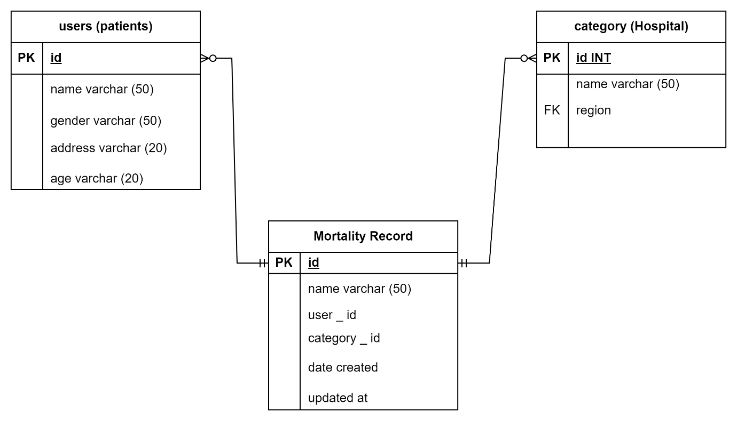

**SQL statements to create the database schema.**

CREATE TABLE Patients (

patient _ id INT PRIMARY KEY,

patient _ name VARCHAR (50),

age INT

gender VARCGHAR (50));

CREATE TABLE Hospitals (

hospital _ id INT PRIMARY KEY,

hospital _ name VARCHAR (50),

region _ id INT,

FOREIGN KEY (region _ id) REFERENCES Region (region _ id));

CREATE TABLE Mortality Records (

records _ id INT PRIMARY KEY,

patient _id INT,

date of death DATE,

cause of death VARCHAR (255);

**Populating the database with sample data**

INSERT INTO Regions (region_ id, region_ name) VALUES (1, 'Rural North'), (2, 'Urban South');

INSERT INTO Hospitals (hospital_ id, hospital_ name, region_ id) VALUES (1, 'North Clinic', 1),

INSERT INTO Patients (patient_ id, patient_ name, age, gender, hospital_ id) VALUES (1, 'Vallen Keiko', 30, 'F', 1),

INSERT INTO Mortality Records (record_ id, patient_ id, date_ of_ death, cause_ of_ death) VALUES (1, 1, '2023-01-15', 'Childbirth complications');

**PART 3: SQL PROGRAMMING**

**Data Retrieval:**

**SELECT R. region_ name, COUNT (M. record_ id) AS mortality_ count**

**FROM Regions R**

**JOIN Hospitals H ON R. region_ id = H. region_ id**

**JOIN Patients P ON H. hospital_ id = P. hospital_ id**

**JOIN Mortality Records M ON P. patient_ id = M. patient_ id**

**GROUP BY R. region_ name;**

**Data Analysis:**

**SELECT I. intervention_ description, COUNT (M. record_ id) AS mortality_ reduction**

**FROM Interventions I**

**JOIN Regions R ON I. region_ id = R. region_ id**

**LEFT JOIN Hospitals H ON R. region_ id = H. region_ id**

**LEFT JOIN Patients P ON H. hospital_ id = P. hospital_ id**

**LEFT JOIN Mortality Records M ON P. patient_ id = M. patient_ id**

**WHERE M. date_ of_ death > '2023-01-01'**

**GROUP BY I. intervention_ description;**

**PART 5:**

**Importing data into Excel and ensuring consistency involves several steps:**

**1. Open a new Excel workbook or use an existing one.**

**2. Click on the "Data" tab in the Excel ribbon.**

**3. In the "Get & Transform Data" group, click on "From Other Sources" and then select "Text from File."**

**4. A file explorer window will appear, allowing you to navigate to the location of the text file containing the data you want to import. Select the file and click on "Open."**

**5. The "Text Import Wizard" will open. In the first step, select the delimiter used in the text file (such as a comma, semicolon, or tab) and click on "Next."**

**6. In the second step, select the data type for each column in the text file (such as General, Text, or Date) and click on "Next."**

**7. In the third step, review the imported data and make any necessary adjustments, such as changing the of a column or mapping the data to different columns. Click on "Finish" to import the data into Excel.**

**8. Once the data is imported, you can use various tools in Excel, such as the "Data Validation" feature, to ensure consistency and accuracy in the data.**

**9. To ensure consistency, you can also use Excel's built-in functions, such as the "COUNTIF" and "IF" functions, to perform data validation and error checking.**

**10. Finally, it's important to regularly review and update the data in Excel to ensure that it remains consistent and accurate.**

**PART 6:**

**PITCH DECK**

**This is presentation by Wonderslide. Link: <https://wonderslide.com/s/0zpj4mzd/>**